1) If you type the following code in the console window, what result will you get?

3 > 2 > 1 === false

//// true/////

///////////////////////////////

2) If the value of x is 40, then what is the output of the following program?

(x % 10 == 0)?

////true/////

//////////////////////////////

3) Which is the correct way to write a comment in JavaScript?

a) {#...#} b) <!---.......---!> c) //…… d) \\ …..

////d /////

///////////////////////////////

4)Wich one of the following is correct?

a) i=+1 b) i+=1 c) i=i++1 d) +i+

////b/////

///////////////////////////////

1. How do you declare a variable in javascript and give a short explanation of their difference?

////

let name = "mori";

undefined

name

'mori'

const hiWord = 369

undefined

hiWord

369

Explanation :

1- Use const if the value should not be change.

2- When use let we can not change the value of the variable after set the variable but in var we can change value of variable.

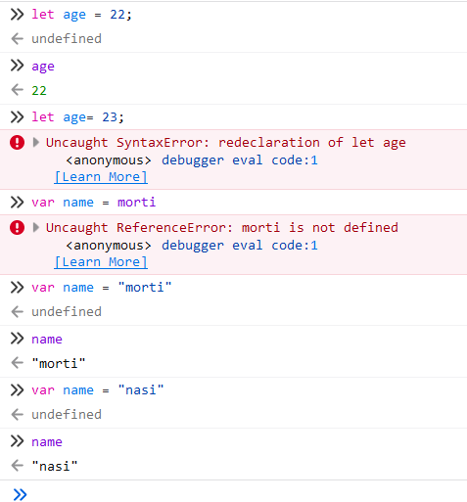

///// ///////////////////////////////

1. What is null in javascript?

////

expresses a lack of identification, indicating that a variable points to no object. ////

///// ///////////////////////////////

1. What will (1== “1”) return ?

////true/////

///////////////////////////////

8)at first declare a variable and give it a value.then type the name of the variable and its value in the console. ////

let name = "mori"

undefined

name

'mori'

/////

/////////////////////////////// 9) for assigning a value to a variable we use:

1. *
2. **= true**
3. -
4. x